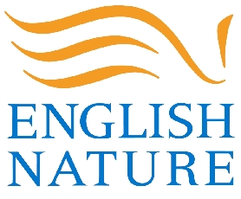
FENN'S, WHIXALL &
BETTISFIELD MOSSES

NATIONAL NATURE RESERVE

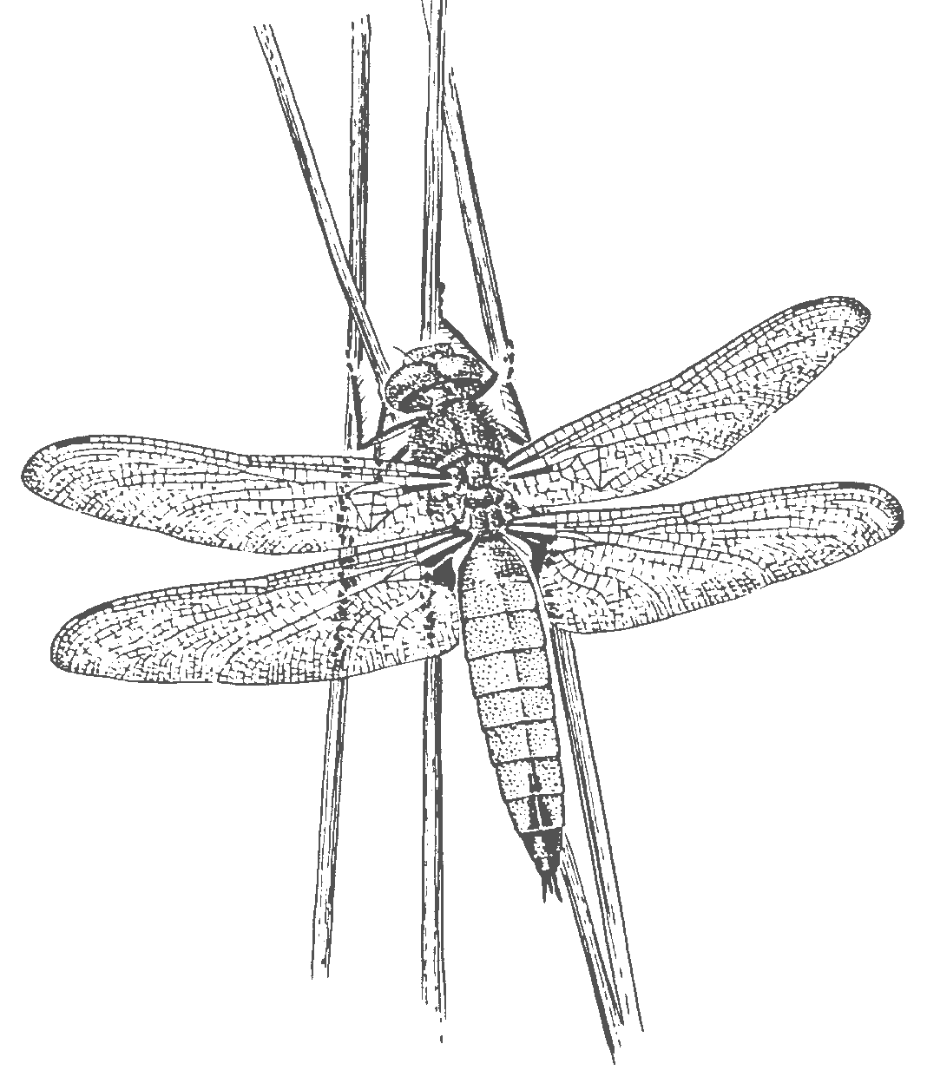
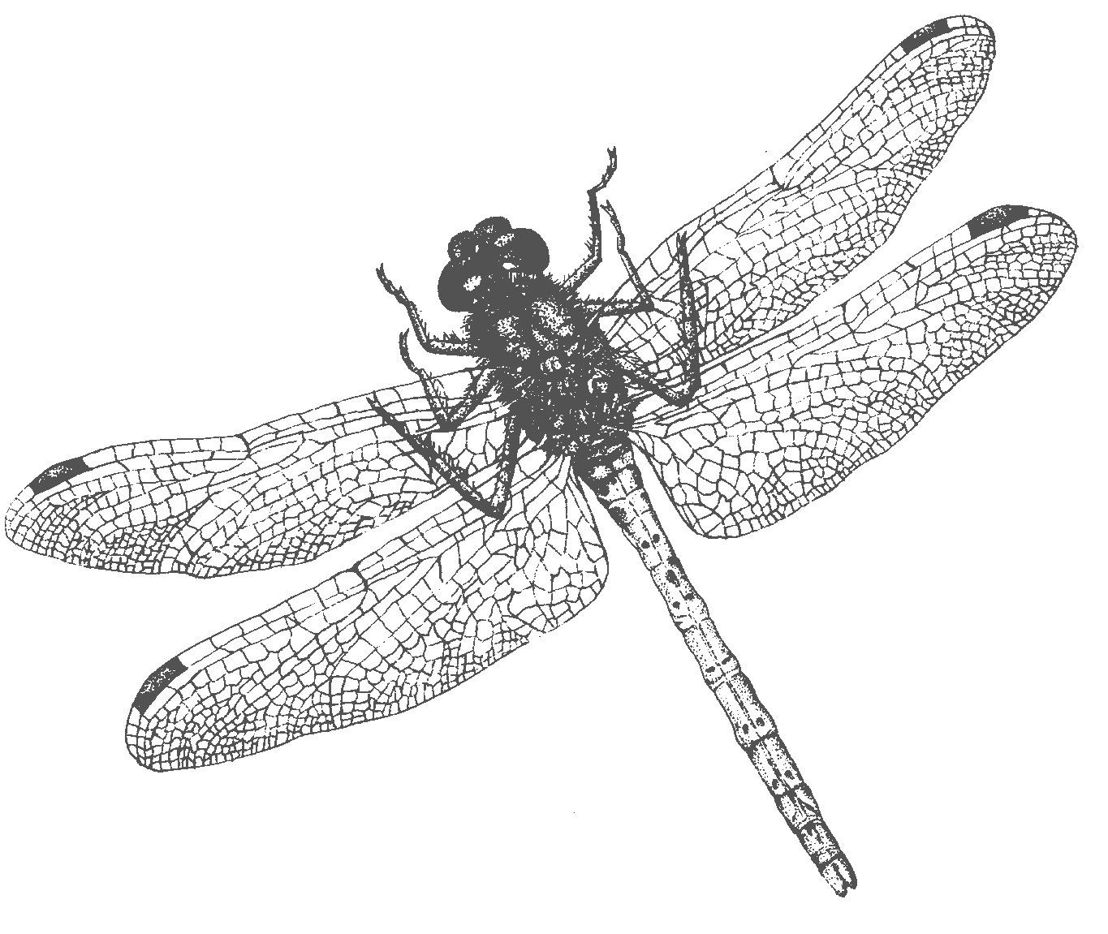
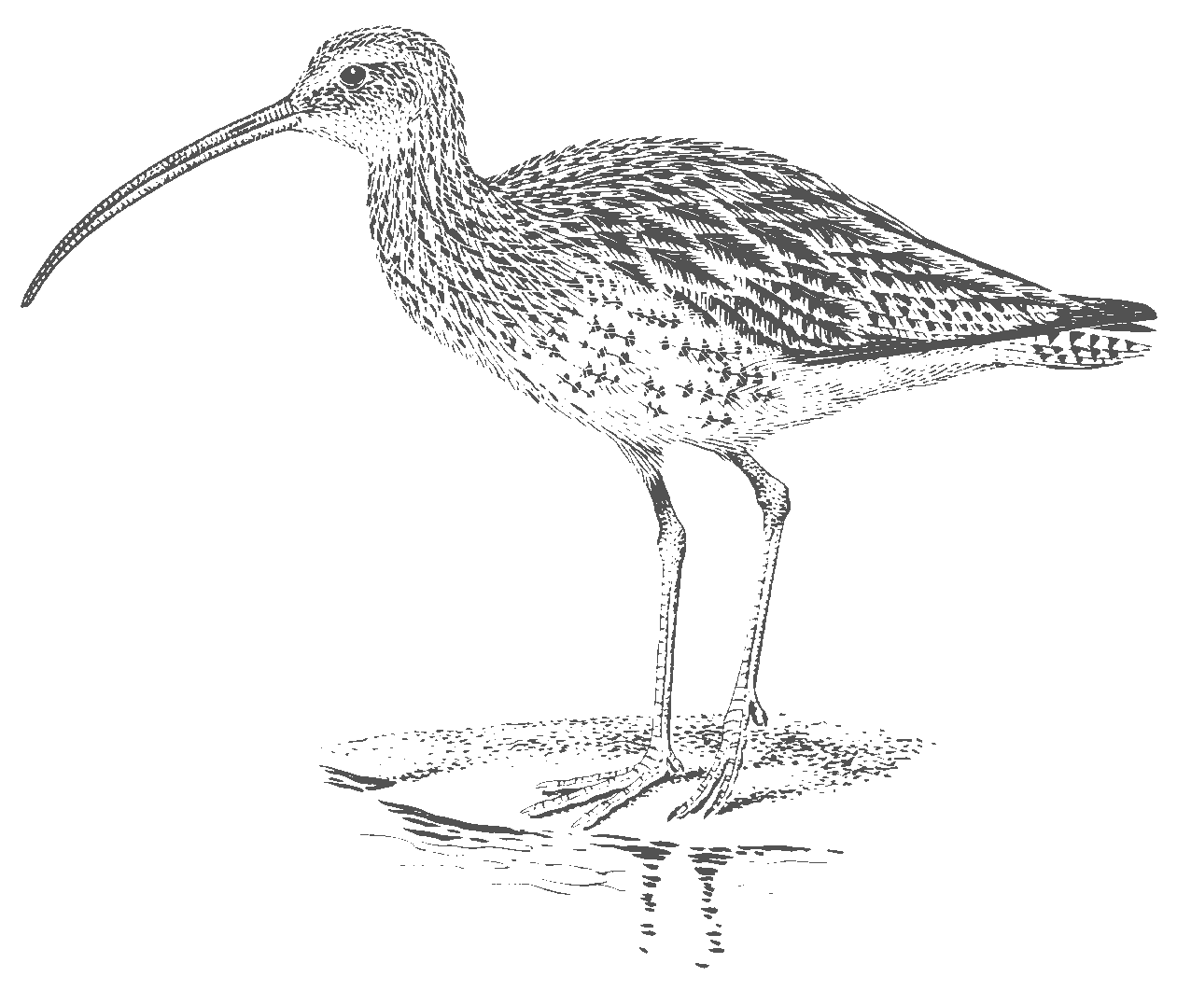
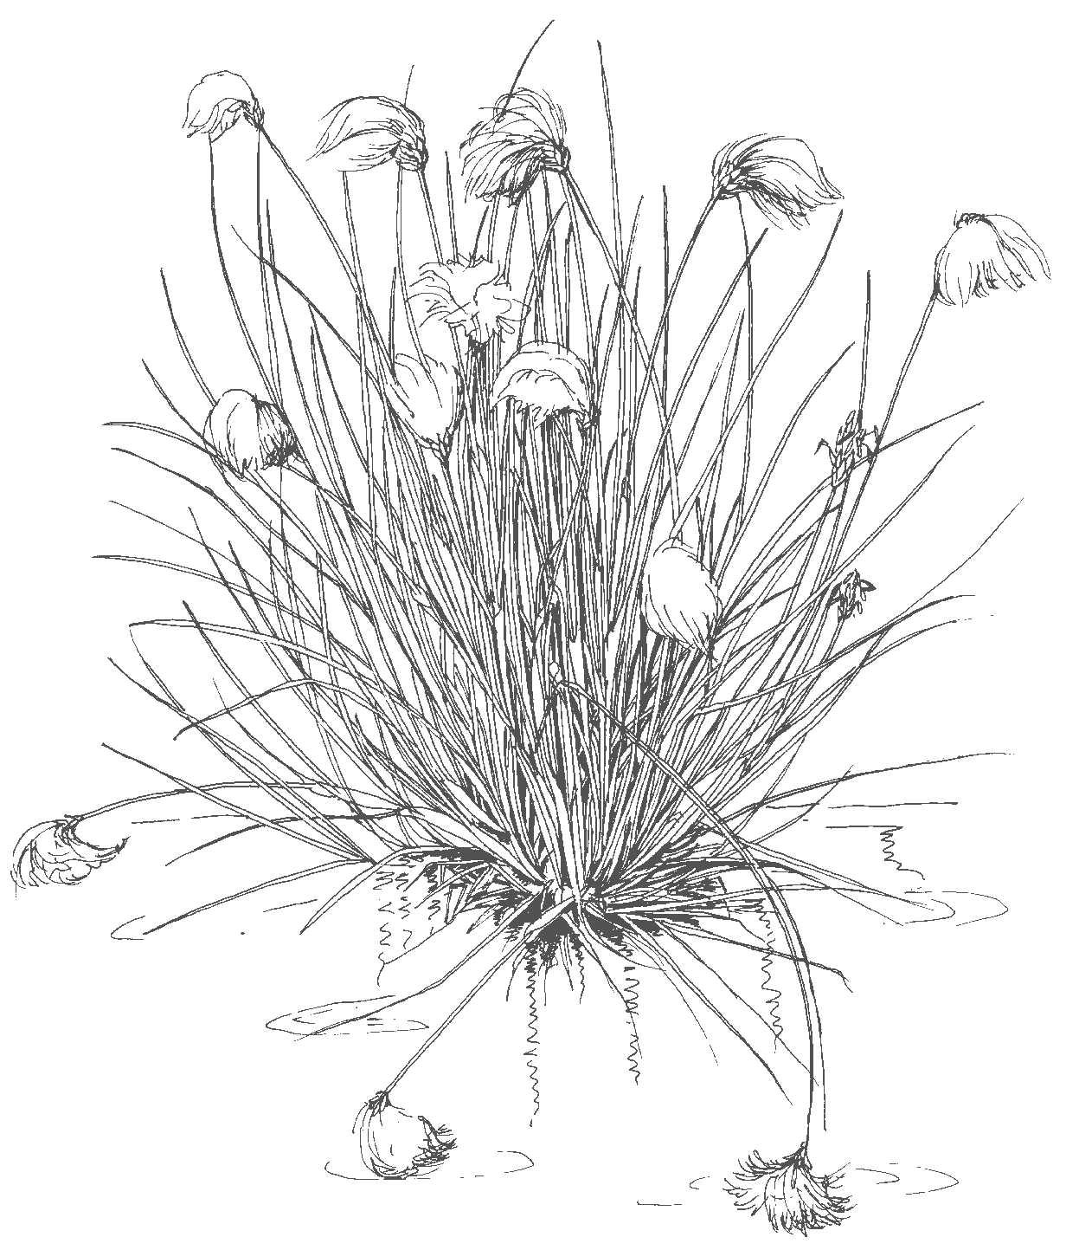
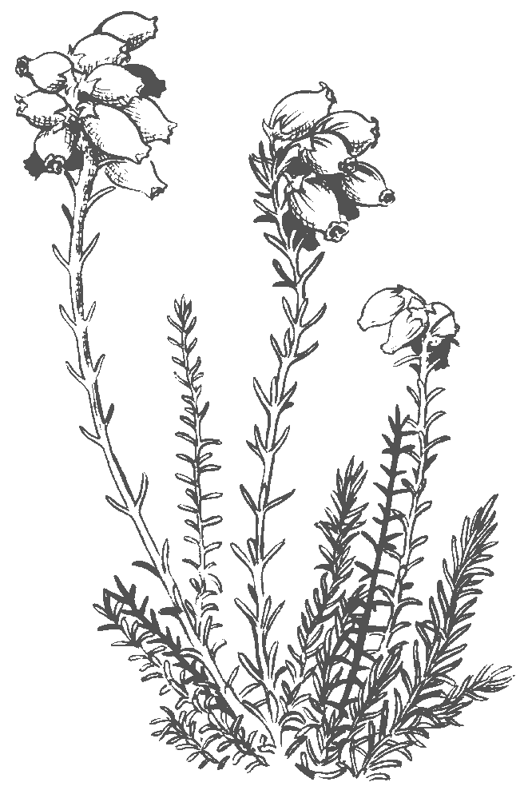
Events 2005

Wed 2 February ‘Willow weaving for your garden’ workshop, 10am - 4pm., English Nature Manor House NNR Base, Moss Lane, Whixall, Phil Pearce and Peter Boardman - to celebrate World Wetlands Day. www.ramsar.org

March 14-22 Bettisfield Church Exhibition and Fenn’s Moss Trails, 10am – 4pm daily. Learn about the wildlife and history of the Mosses - part of the Open Churches Network and Wrexham Science Festival. Refreshments. www.wrexhamsf.com

Wed 16 March ‘Birds of the Mosses’ slideshow, 7.00pm, North East Wales Institute Room B53, and again on Thurs 17 March, 2pm, Bersham Heritage Centre, (no need to book), Joan Daniels - part of the Wrexham Science Festival to celebrate National Biodiversity month. www.wrexhamsf.com
Sun 24 April ‘Birds of the Mosses’ Walk, 1.30 for 2pm start, Manor House, Estelle Hughes and Eric Marsh. – to celebrate International Compost Awareness Week. www.compost.org.uk

Sun 22 May ‘An Introduction to the Mosses’ Walk, 2pm, Morris’s Bridge, Peter Boardman - to celebrate International Day for Biological Diversity www.biodiv.org

Sun 12 June ‘Make an Insect’ Morning and ‘Insects on the Mosses’ Afternoon Walk, 10am and 2pm, Manor House, Peter Boardman - to celebrate Wales Biodiversity Week (11 -19 June), www.ccw.gov.uk & National Insect Week www.nationalinsectweek.co.uk
Sat 9 July ‘National Moth Hunt’, 12.30pm, Morris’s Bridge, Peter Boardman, Shropshire Moth Group. Search for day-flying moths on the Mosses - to celebrate National Moth Night., www.nationalmothnight.info

Sun 31 July ‘Woodcarving on the Mosses’ Day (including walk to fetch bog pine and look at the Sculpture Trail) – 11am - 3.30pm, Manor House, David Gerty of British Woodcarvers - to celebrate International Bog Day www.bwa-woodcarving.fsnet.co.uk

Sun 7 August ‘Dragonfly Day’, 1.00 pm – 4 pm, Manor House, Pete Boardman. An afternoon walk to see the wealth of dragonflies on the Mosses.– a Natura 2000 Site Green Day Event, www.eurosite-nature.org

Wed 10 Aug ‘Bog Creatures Biodiversity Workshop’ for children, 9.30am – 4.00pm, Manor House, Pete Boardman and Ian Cheeseborough.

Sun 11 Sept ‘Creative Writing on The Mosses’ 12.30 – 4.30pm, Manor House. A creative writing afternoon and picnic tutored by Gladys Mary Coles, author of ‘The Echoing Green’ - £1.50.

Sun 25 Sept ‘Fungal Foray’ on Fenn’s Moss – 2 pm, Bettisfield old railway station, Roy Mantle, Shropshire Fungus Group. www.britmycolsoc.org.uk/
Wed 9 November ‘10,000 years on the Mosses’ slideshow, 7.30pm, Edward German Room, Whitchurch Civic Centre, and Wed 23 November, 7.30pm, Senior Club, Chapel Street, Wem, Joan Daniels. Free refreshments. (No need to book.)
Sun 4 Dec – Come and cut a Xmas Tree, 10.30 am – 1.00 pm, A495 Fenn’s Bank lay-by, Ian Cheeseborough – to celebrate International Volunteers Day. www.seeyn.org

All events except talks MUST be booked in advance by contacting Joan Daniels on 01948 880362 on weekdays, or 07974 784799 on weekends and are free unless stated
(e-mail joan.daniels@english -nature.org.uk, or visit www.english-nature.org.uk)

