 | 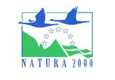 | 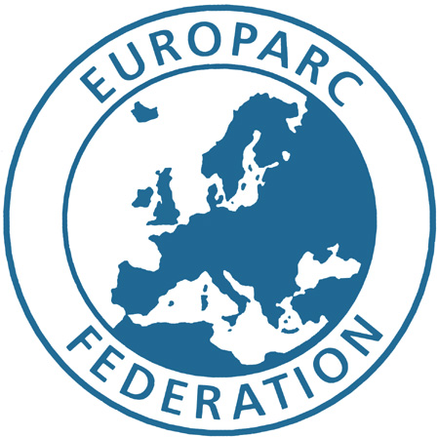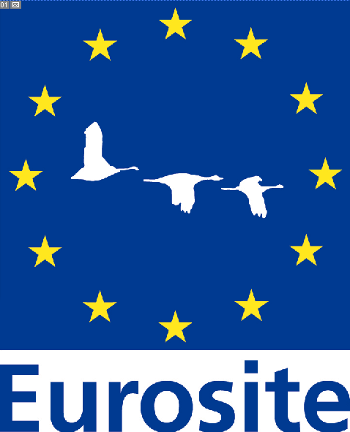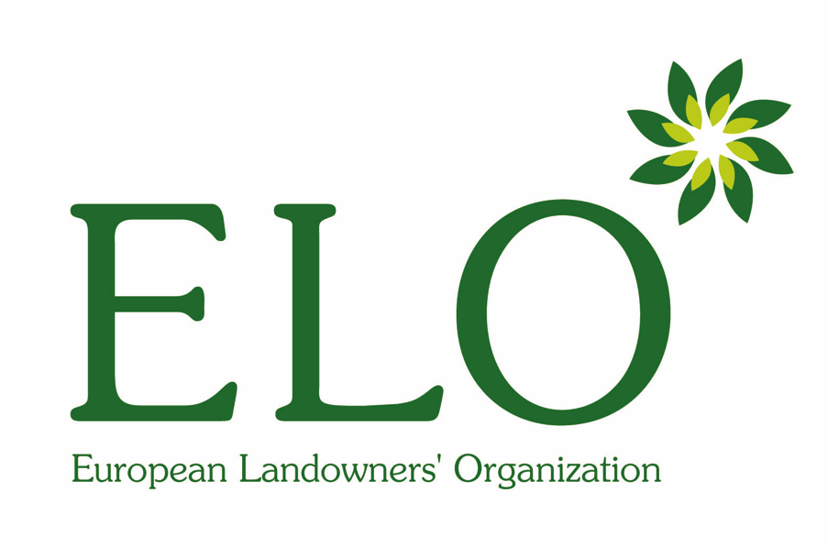
Natura 2000 Networking Programme on behalf of the European Commission | [Your logo here ] | Natura 2000 Networking Programme managed in partnership by project partners EUROPARC Federation, Eurosite and European Landowners Organization (ELO)

PRESS RELEASE

Your organisation / estate - Your contact address
Your name - Your e-mail address - Your telephone / fax number

Green Days come to your site / estate name

On the date – your site / estate name will be celebrating its Natura 2000 status, as an important part of the worlds largest network of protected areas.

Title of your event

…description of your event – what you will be doing, where you will do it, and why - including times and where to meet, etc…

Natura 2000 describes the network of sites protected under European Commission’s Habitats and Birds Directives. Set to cover some 20% of European Union territory, the Natura 2000 network is a response to public concern over the loss of European biodiversity and commitment made by Europe’s heads of State and Government in Gothenburg 2001 – to ‘halt the loss of biodiversity by 2010’.

Natura 2000 is about ‘people and nature’, and not ‘nature without people’. Natura 2000 recognises the traditional and economic importance of nature to Europeans, respecting local and regional natural values and seeking to conserve Europe’s natural environment through compatible land-uses and sustainable development. Natura 2000 will become an increasingly important tool in maintaining rural diversity and the rural economy.

The objective of Green Days is to promote the importance of Natura 2000 at the local level, raising awareness of the role of Natura 2000 in the conservation of Europe’s natural heritage, maintaining and supporting rural diversity and economy. Green Days is part of the Natura 2000 Networking Programme, that also seeks to improve the management of Natura 2000 sites through the promotion of examples of good site management practice on Natura 2000 sites throughout Europe.

For more information about Natura 2000, Green Days and the Natura 2000 Networking Programme, visit www.natura.org

