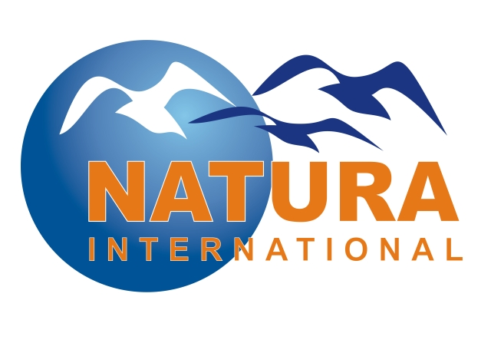
Sustainability of Natura 2000
Combining environmental, social and economic benefits

17-18 October 2007, Peterborough, United Kingdom

Workshop Logistics

Venue
The workshop will be held in Natural England’s offices located in the centre of Peterborough.

Address: Northminster House, Northminster Rd, Peterborough, PE1 1UA
Tel: 0044 (0) 1733 455000

Directions: Please download the directions: http://www.natura-international.org/NE%20directions.pdf

Registration
To register, please complete and email the booking form by 5 October, together with your payment (instructions below).

Accommodation and transport
We have pre-booked single rooms in Hotel Ramada for 16-18 October. Please indicate if you wish to stay in this hotel or prefer to stay in the accommodation of your choice by 5 October. After this date we cannot guaranty the availability of rooms. The transport between Hotel Ramada and the venue is included in the price of the hotel. The transport is covered only for 17-18 October.

Hotel address: Ramada Hotel Peterborough, Thorpe Meadows, Peterborough, PE3 6GA
Tel: 0044 1733 564240

Website and directions: http://www.ramada.com/Ramada/control/Booking/property_info?propertyId=15929&brandInfo=RA
Dietary requirements
When booking, please advise us if you have any special dietary requirements

Registration Form

Family name and first name:
Organisation:
Address:
Postal code and town:
Country:
Telephone:
Fax:
E-Mail:
Workshop booking options (including VAT):

Please note that there is a substantial discount for the first 20 participants from the NNP network or Eastern Europe. Please contact Daniel Piec (details below) for more information.

Day Participant, Wednesday 17/10: £55 [ ]
Day Participant, Thursday 18/10: £55 [ ]

Single room Hotel Ramada, 16/10: £75 [ ]
Single room Hotel Ramada, 17/10: £75 [ ]
Single room Hotel Ramada, 18/10: £75 [ ]

Dinner in Hotel Ramada, 16/10: £20 [ ] Dietary requirements:______________
Dinner in Hotel Ramada, 17/10: £30 [ ]
Dinner in Hotel Ramada, 18/10: £20 [ ]

Total: [£_____]
Payment options
I enclose a cheque for the amount of £______ [ ]. See address below.

I have paid the amount of £ ______ through PayPal [ ]
Information about electronic payment options is available on: www.natura-international.org/nnp_paydetails

Send me the invoice

Signature: Date: / /
Form submission options:
E-MAIL this form to Daniel Piec daniel.piec@natura-international.org

POST it to this address: Natura International, 40 High Street, Gretton, Corby, Northamptonshire, NN17 3DE, UK
CONFIRMATION OF YOUR REGISTRATION WILL BE SENT BY EMAIL AFTER WE HAVE RECEIVED YOUR PAYMENT

